Big Data

# What is Big Data

Data which is very large in size is called Big Data. Normally we work on data of size MB(WordDoc ,Excel) or maximum GB(Movies, Codes) but data in Peta bytes i.e. 10^15 byte size is called Big Data. It is stated that almost 90% of today's data has been generated in the past 3 years.

**Sources of Big Data**

These data come from many sources like

* **Social networking sites:** Facebook, Google, LinkedIn all these sites generate huge amounts of data on a day to day basis as they have billions of users worldwide.
* **E-commerce site:** Sites like Amazon, Flipkart, Alibaba generate huge amounts of logs from which users buying trends can be traced.
* **Weather Station:** All the weather stations and satellites give very huge data which are stored and manipulated to forecast weather.
* **Telecom company:** Telecom giants like Airtel, Vodafone study the user trends and accordingly publish their plans and for this they store the data of its million users.
* **Share Market:** Stock exchange across the world generates huge amounts of data through its daily transactions.

## **5V's of Big Data**

1. **Velocity:** The data is increasing at a very fast rate. It is estimated that the volume of data will double every 2 years.
2. **Veracity.** Being able to identify the relevance and accuracy of data, and apply it to the appropriate purposes. Understanding data relevance is key to value.
3. **Variety.** Being able to leverage the potential of variable data sources and types, both structured and unstructured. Integrating diverse data into a manageable structure is key to a robust big data opportunity.**Variety:** Nowadays data is not stored in rows and columns. Data is structured as well as unstructured. Log file, CCTV footage is unstructured data. Data which can be saved in tables are structured data like the transaction data of the bank.
4. **Volume:** The amount of data which we deal with is of very large size of PetabytesVolume. Creating an ability to ingest, process, and store even large data volumes. This should be scalable for growing business needs, with data produced from both human and machine origins.
5. **Value**. Understanding the potential to create revenue or unlock opportunities through your data. This reflects the outcomes you apply to your data use. If it is not valuable, then questions should be raised about why and when you store it.

**DIFFERENT TYPES OF DATA :**

**1.Structured data :** data which has a defined repeating pattern or is based on primitive data types. Easy to sort,read,process ,analyse and is faster.

Ex: numbers,date,strings

Sources: relational dbs,flat files,etc

**2.Semi structured data:** data that contains tags/markup elements in order to separate elements ,generate hierarchies of records and files.

Ex: table values separated by comma

Sources: web data in the form of cookies(XML),JSON

**3.Unstructured data :** data which has no repeating pattern. Data in unstructured format.

Ex: Metadata,inconsistent data(from files,social media,etc.), diff formats(emails,audio,video,images,etc.)

Sources: social media,mobile data

## **Solution**

**Storage:** This huge amount of data, Hadoop uses HDFS (Hadoop Distributed File System) which uses commodity hardware to form clusters and store data in a distributed fashion. It works on Write once, read many times principle.

**Processing:** Map Reduce paradigm is applied to data distributed over a network to find the required output.

**Analyze:** Pig, Hive can be used to analyze the data.

**Cost:** Hadoop is open source so the cost is no more an issue.

What is Hadoop

Hadoop is an open source framework from Apache and is used to store, process and analyze data which are very huge in volume. Hadoop is written in Java and is not OLAP (online analytical processing). It is used for batch/offline processing.It is being used by Facebook, Yahoo, Google, Twitter, LinkedIn and many more. Moreover it can be scaled up just by adding nodes in the cluster.

**HADOOP ARCHITECTURE**

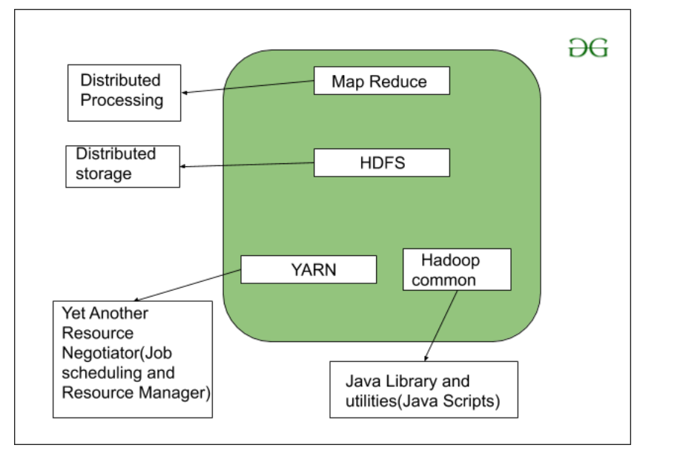

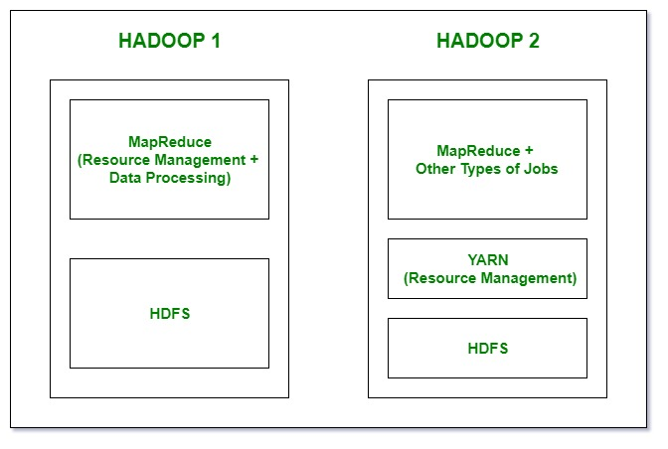

## **Modules of Hadoop**

### HDFS(Hadoop Distributed File System)

is utilized for storage permission is a Hadoop cluster. It is mainly designed for working on commodity Hardware devices(inexpensive devices), working on a distributed file system design. HDFS is designed in such a way that it believes more in storing the data in a large chunk of blocks rather than storing small data blocks.

### **YARN(Yet Another Resource Negotiator)**

YARN is a Framework on which MapReduce works. YARN performs 2 operations that are Job scheduling and Resource Management. The Purpose of Job schedular is to divide a big task into small jobs so that each job can be assigned to various slaves in a Hadoop cluster and Processing can be Maximized. Job Scheduler also keeps track of which job is important, which job has more priority, dependencies between the jobs and all the other information like job timing, etc. And the use of Resource Manager is to manage all the resources that are made available for running a Hadoop cluster.

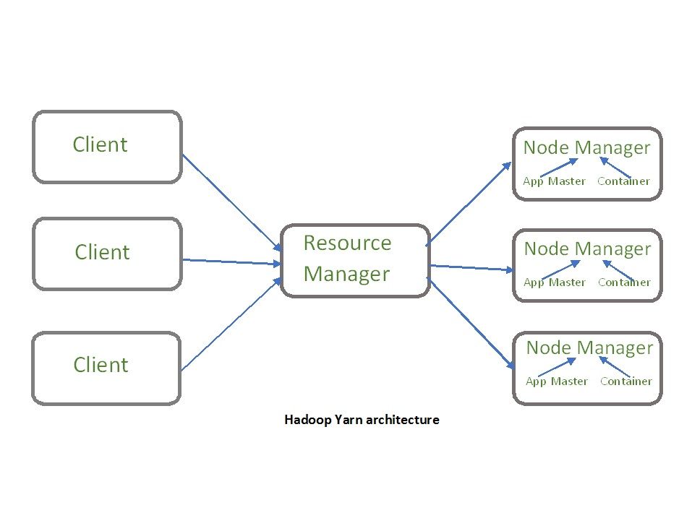

**SCHEDULING IN YARN : FIFO, CAPACITY, FAIR SCHEDULER**

**( By default capacity scheduler used)**

Yarn follows scheduling methods to allocate resources

1. **FIFO : resources allocated on First In First Out Basis**

---the 1st requested will be allocated resources first , other tasks will wait till 1st completed

**Drawback:** FIFO will cause huge wait times, FIFO SCHEDULER rarely used.

1. **CAPACITY SCHEDULER : capacity distributed to different queues :**

----each queue allocated share of cluster resources

---- jobs can be submitted to specific queue;

---- inside queue FIFO is followed;

------->allows small jobs to complete without getting stuck due to large ones

**Drawback:** cluster might be underutilized since capacity is reserved for queues.

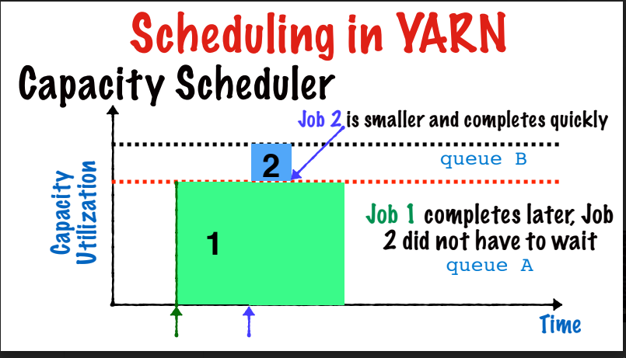

1. **FAIR SCHEDULER :** NO wait time; Resources always proportionally allocated to all jobs;

J1 gets all resources ,after J2 takes half, when J3 comes it takes half and after J2

completes resources divides between J1 and J2 in this way all resources divides between jobs

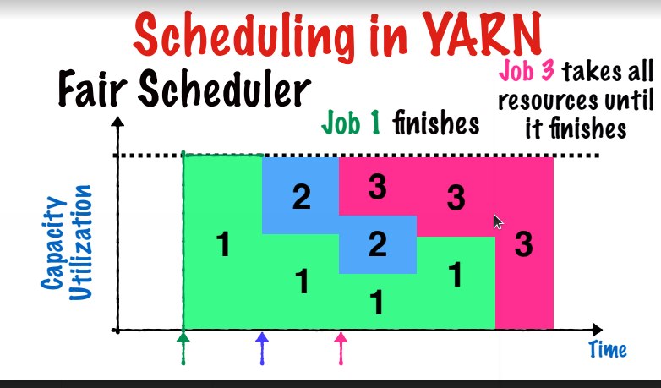

**DELAY SCHEDULING :** when request for specific location constraint is not available we delay the scheduling of jobs

**Enable FIFO scheduler in Hadoop YARN: Changes to be done in yarnsite.xml as below:**

<property>

<name>yarn.resourcemanager.scheduler.class</name>

<value>org.apache.hadoop.yarn.server.resourcemanager.scheduler.fifo.FifoScheduler

</value>

</property>

**Enable Capacity Scheduler in Hadoop YARN :Changes to be done in yarnsite.xml as below:**

<property>

<name>yarn.resourcemanager.scheduler.class</name>

<value>org.apache.hadoop.yarn.server.resourcemanager.scheduler.capacity.Capacity

Scheduler</value>

</property>

copy the yarn-site.xml and capacity-scheduler.xml files to all nodes in the cluster. Then

restart the Resource manager and Node manager daemons.

**Enable Fair scheduler in Hadoop YARN:Changes to be done in yarnsite.xml as below:**

<property>

<name>yarn.resourcemanager.scheduler.class</name>

<value>org.apache.hadoop.yarn.server.resourcemanager.scheduler.fair.FairScheduler

</value>

</property>

copy the yarn-site.xml and fair-scheduler.xml files to all nodes in the cluster. Then

restart the Resource manager and Node manager daemons.

### **MapReduce**

MapReduce is nothing but just like an Algorithm or a [data structure](https://www.geeksforgeeks.org/data-structures/) that is based on the YARN framework. The major feature of MapReduce is to perform the distributed processing in parallel in a Hadoop cluster which Makes Hadoop working so fast. When you are dealing with Big Data, serial processing is no more of any use. MapReduce has mainly 2 tasks which are divided phase-wise:

In the first phase, **Map** is utilized and in next phase **Reduce** is utilized.

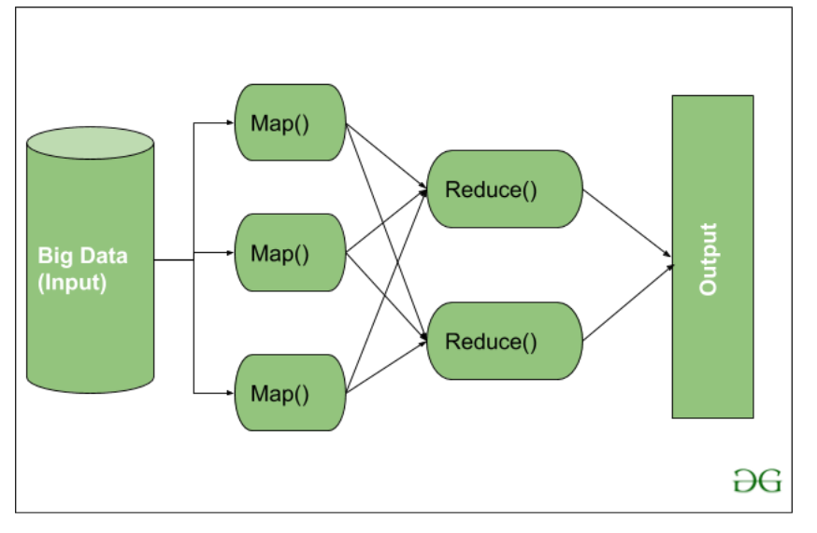

Here, we can see that the *Input* is provided to the Map() function then it’s *output* is used as an input to the Reduce function and after that, we receive our final output. Let’s understand What this Map() and Reduce() does.

As we can see that an Input is provided to the Map(), now as we are using Big Data. The Input is a set of Data. The Map() function here breaks these DataBlocks into **Tuples** that are nothing but a key-value pair. These key-value pairs are now sent as input to the Reduce(). The Reduce() function then combines this broken Tuples or key-value pair based on its Key value and form set of Tuples, and performs some operation like sorting, summation type job, etc. which is then sent to the final Output Node. Finally, the Output is Obtained.

The data processing is always done in Reducer depending upon the business requirement of that industry. This is How First Map() and then Reduce is utilized one by one.

**Hadoop Common:** These Java libraries are used to start Hadoop and are used by other Hadoop modules.

## **Where to use HDFS**

* **Very Large Files:** Files should be of hundreds of megabytes, gigabytes or more.
* **Streaming Data Access:** The time to read the whole data set is more important than latency in reading the first. HDFS is built on a write-once and read-many-times pattern.
* **Commodity Hardware:**It works on low cost hardware.

## **Where not to use HDFS**

* **Low Latency data access:** Applications that require very less time to access the first data should not use HDFS as it is giving importance to whole data rather than time to fetch the first record.
* **Lots Of Small Files:**The name node contains the metadata of files in memory and if the files are small in size it takes a lot of memory for the name node's memory which is not feasible.
* **Multiple Writes:**It should not be used when we have to write multiple times.

## **HDFS Concepts**

1. **Blocks:** A Block is the minimum amount of data that it can read or write.HDFS blocks are 128 MB by default and this is configurable.Files in HDFS are broken into block-sized chunks,which are stored as independent units.Unlike a file system, if the file is in HDFS is smaller than block size, then it does not occupy full block?s size, i.e. 5 MB of file stored in HDFS of block size 128 MB takes 5MB of space only.The HDFS block size is large just to minimize the cost of seek.
2. **Name Node:** HDFS works in master-worker pattern where the name node acts as master.Name Node is controller and manager of HDFS as it knows the status and the metadata of all the files in HDFS; the metadata information being file permission, names and location of each block.The metadata are small, so it is stored in the memory of name node,allowing faster access to data. Moreover the HDFS cluster is accessed by multiple clients concurrently,so all this information is handled by a single machine. The file system operations like opening, closing, renaming etc. are executed by it.
3. **Data Node:** They store and retrieve blocks when they are told to; by client or name node. They report back to the name node periodically, with a list of blocks that they are storing. The data node being a commodity hardware also does the work of block creation, deletion and replication as stated by the name node.

HDFS DataNode and NameNode Image:

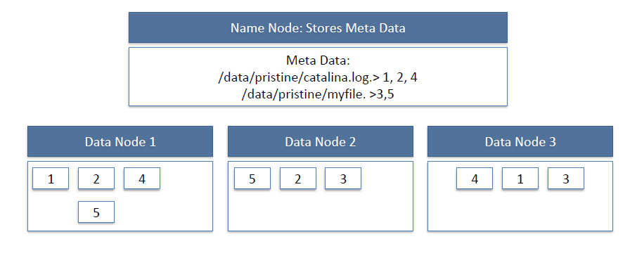

HDFS Read Image:

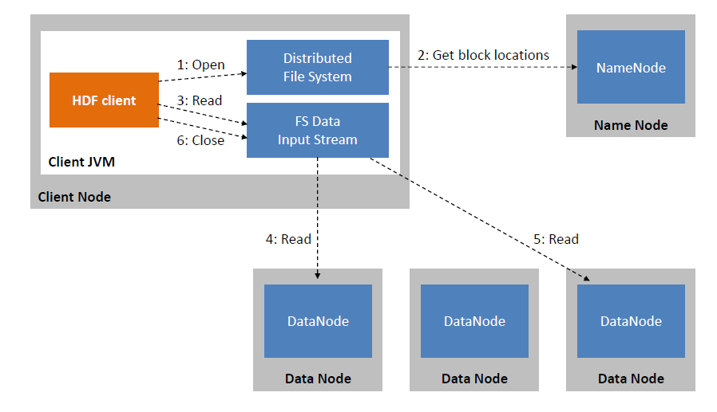

HDFS Write Image:

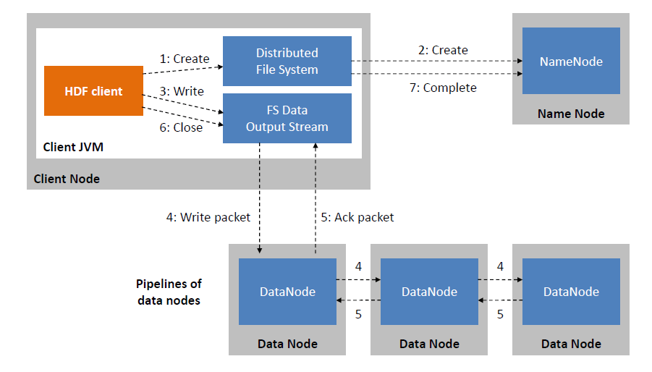

Since all the metadata is stored in the name node, it is very important. If it fails the file system can not be used as there would be no way of knowing how to reconstruct the files from blocks present in the data node. To overcome this, the concept of a secondary name node arises.

**Secondary Name Node:** It is a separate physical machine which acts as a helper of name nodes. It performs periodic check points.It communicates with the name node and takes a snapshot of metadata which helps minimize downtime and loss of data.

### HADOOP: SINGLE-NODE VERSUS MULTI-NODE

A. Single-Node Cluster

Single-node cluster is a method of implementing and setting all daemons on a single virtual machine. This setup method is generally used for the study and the test phase, or in environments with fewer data, but in this case, maybe Hadoop is not the most recommended technology to store data. If the volume of data is not large enough then you can hardly notice the main advantages of Hadoop from the first place. After installing, configuring, and starting ssh processes of a Single- node cluster, launching the jps command, which is a java virtual machine process status tool, we can see the status of all Hadoop daemons like NameNode, Secondary NameNode, JobTracker, TaskTracker, DataNodes that are currently running on the machine. As we can see in Fig. 2, they all run on the same virtual machine that we name vmdatalake1.

B. Multi-Node Cluster

Setting Hadoop in a Multi-node cluster involves the use of more than one virtual machine VM. Each data node runs basically on a different VM. This type of configuration is used in organizations to analyze BigData. In the real environment when you are dealing with petabytes of data, this data must be distributed in hundreds of machines to be processed in real- time. Next, we can see the implementation of a Multi-node cluster using the same system environment as in Single-node cluster. We configured six virtual machines (Fig. 2) by cloning the VM from the Single-Node cluster, each of which we set it up after for specific purposes. By running the same java jps command on each VM you can see which daemons are running on each dedicated VM, where NN corresponds to the VM dedicated to the NameNode, JT to JobTracker, SNN to Secondary NameNode, DNn to DataNodes: DN1, DN2, DN3. Fig. 3 is a capture launched from another computer connected to the same LAN over the MobaXterm app by using Write commands on all terminals

Installation of Hadoop

sudo apt update

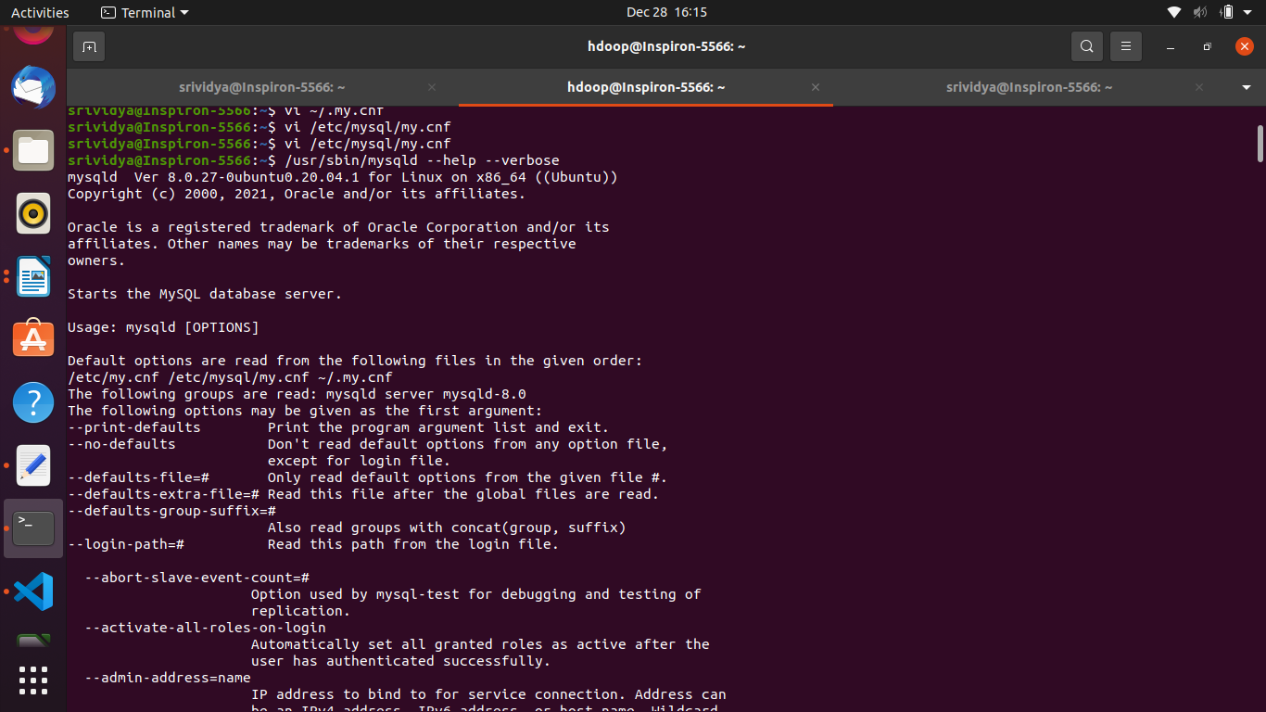

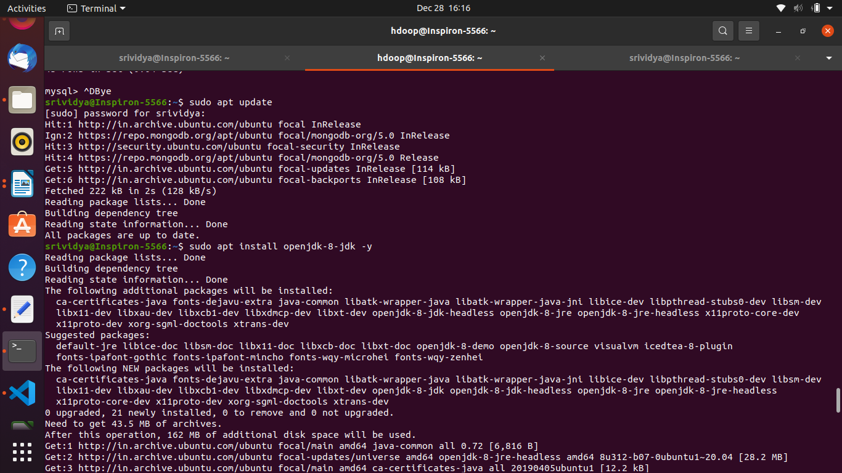

**$sudo apt install openjdk-8-jdk openjdk-8-jre**

**$ java -version (to get version)**

**sudo apt install openssh-server openssh-client -y**

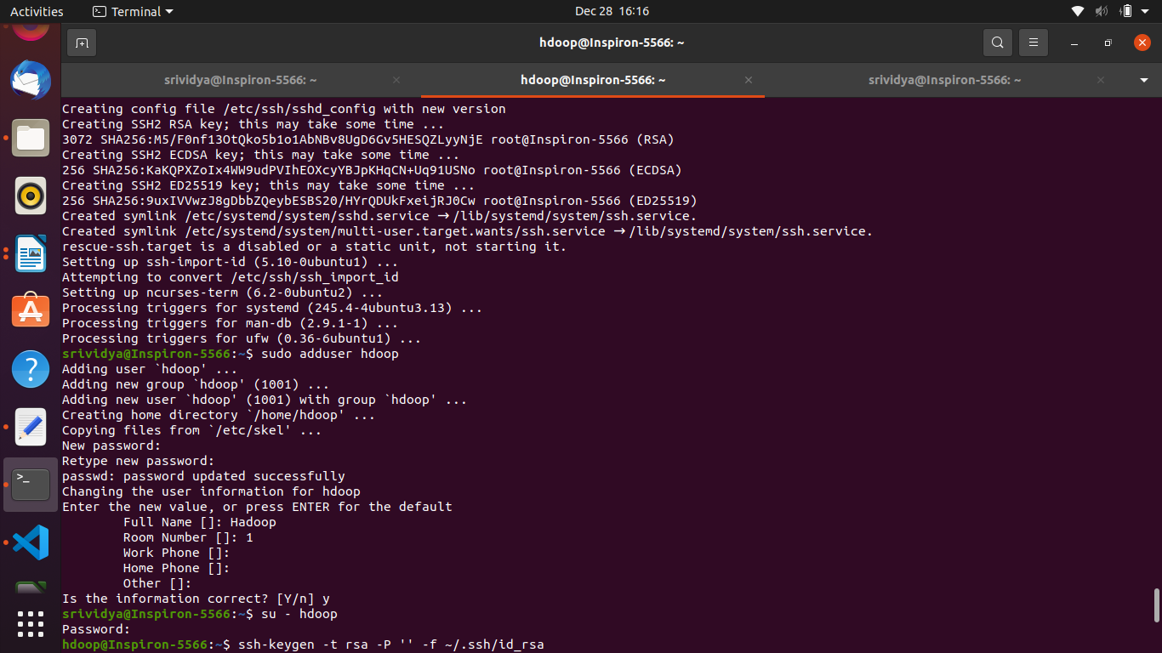

sudo adduser hdoop

su - hdoop

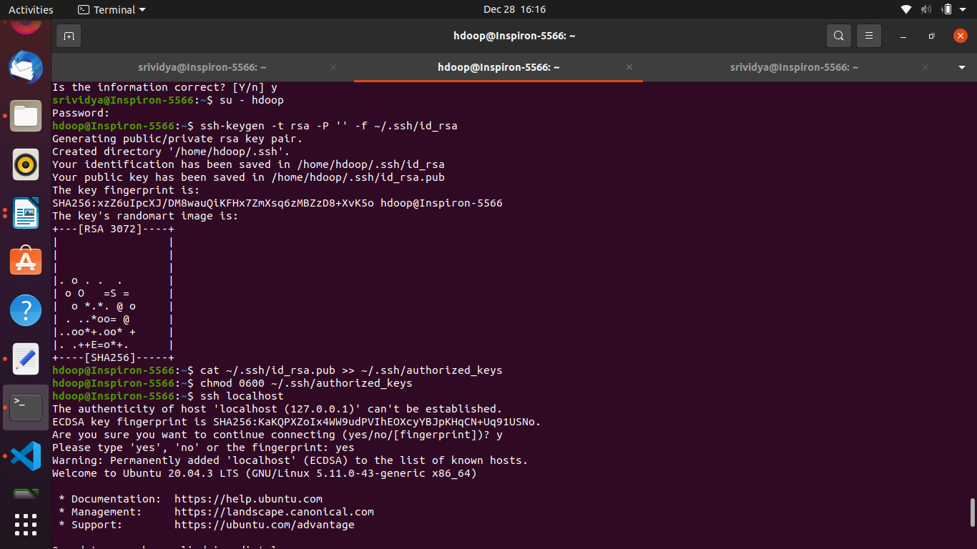

ssh-keygen -t rsa -P '' -f ~/.ssh/id_rsa

cat ~/.ssh/id_rsa.pub >> ~/.ssh/authorized_keys

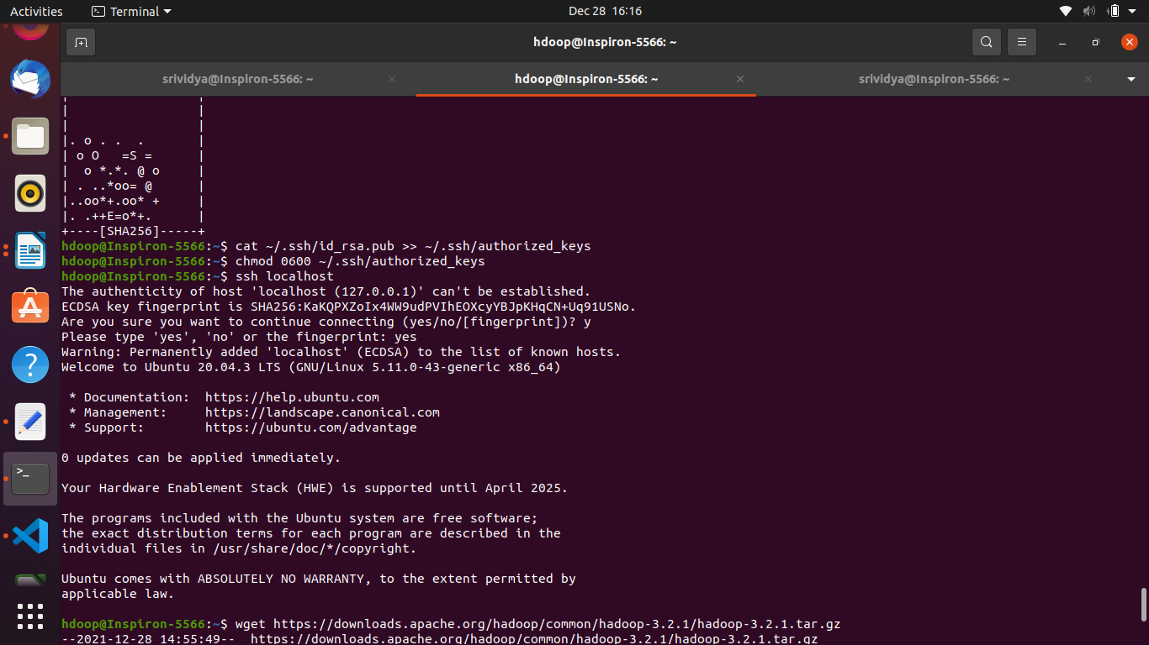

chmod 0600 ~/.ssh/authorized_keys

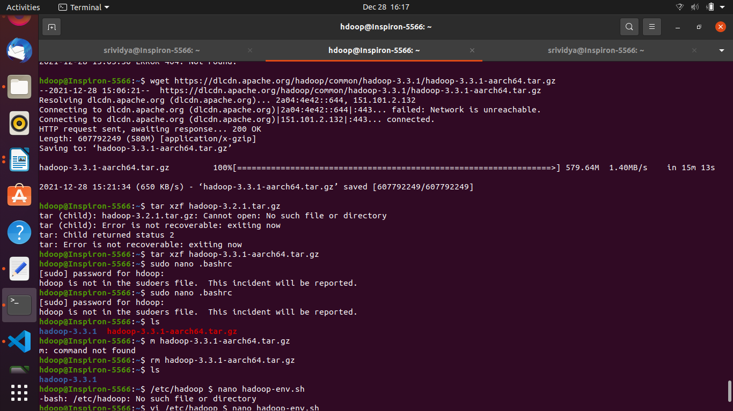

ssh localhost

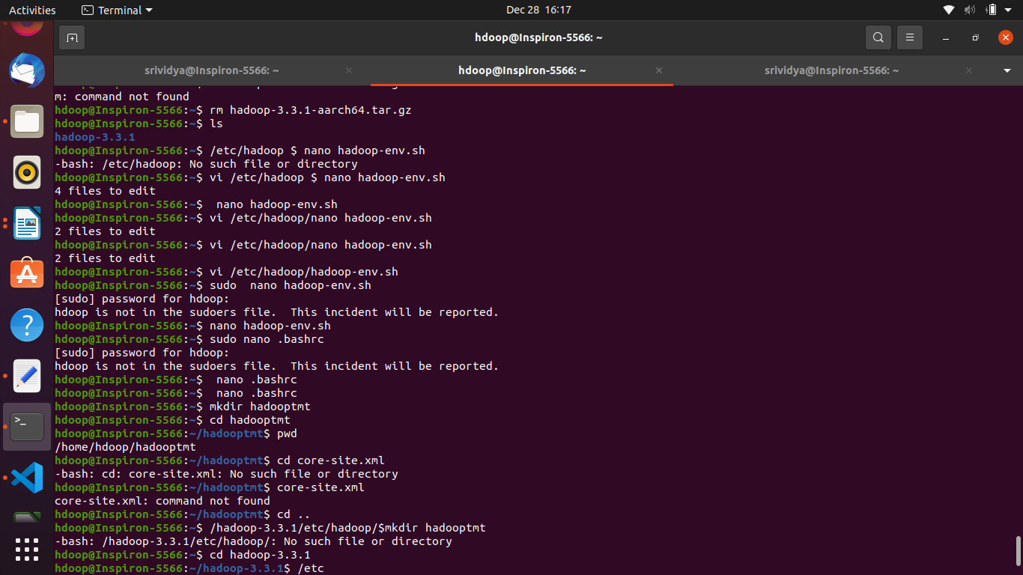

**Go to apache official website and download apache hadoop 3.3.1 version binary64 ----> backupsites copy link**

**In terminal**

**$wget (paste link) https://downloads.apache.org/hadoop/common/hadoop-3.3.1/hadoop-3.3.1-aarch64.tar.gz**

**$ sudo nano .bashrc**

export **JAVA_HOME=/usr/lib/jvm/java-8-openjdk-amd64**

export **HADOOP_HOME=/home/hadoop-3.3.1**

export HADOOP_INSTALL=$HADOOP_HOME

export HADOOP_MAPRED_HOME=$HADOOP_HOME

export HADOOP_COMMON_HOME=$HADOOP_HOME

export HADOOP_HDFS_HOME=$HADOOP_HOME

export YARN_HOME=$HADOOP_HOME

export HADOOP_COMMON_LIB_NATIVE_DIR=$HADOOP_HOME/lib/native

export HADOOP_OPTS="-Djava.library.path=$HADOOP_HOME/lib"

export PATH=$PATH:$HADOOP_HOME/sbin:$HADOOP_HOME/bin:$JAVA_HOME/bin

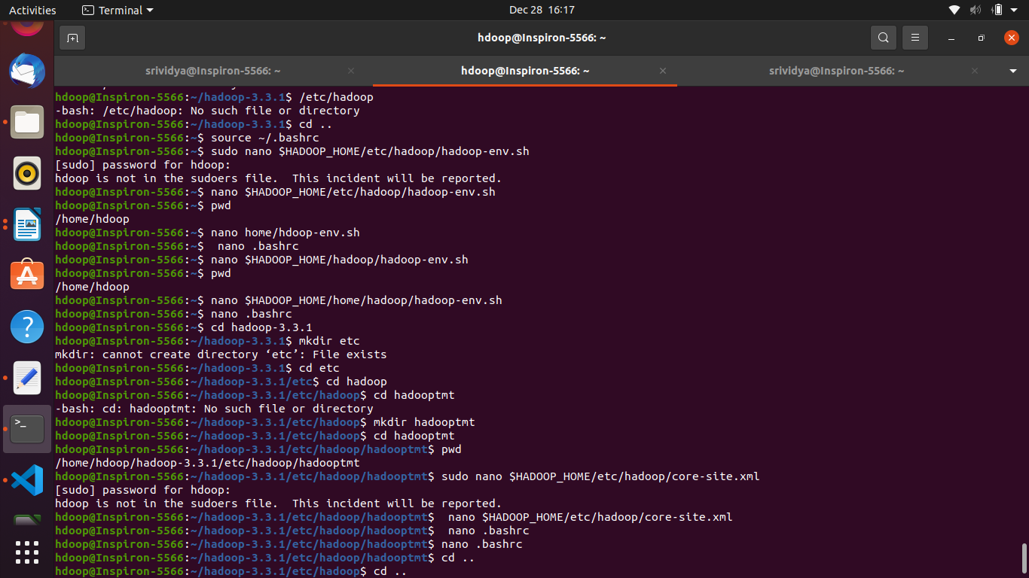

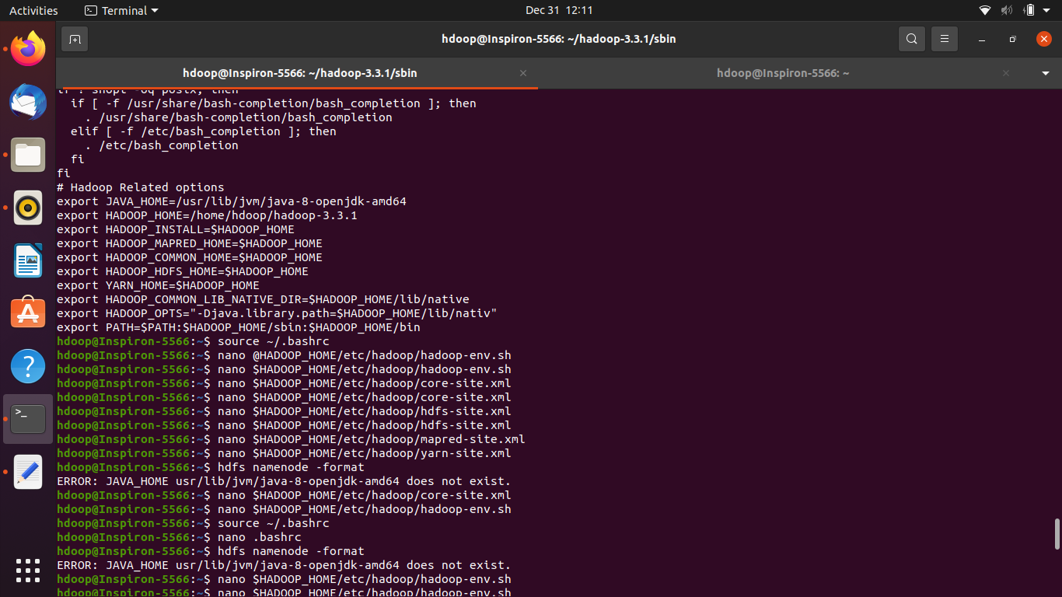

In the unpacked Hadoop directory go to etc/hadoop/hadoop-env.sh Update the JAVA_HOME to your java home directory

$ nano $HADOOP_HOME/etc/hadoop/hadoop-env.sh

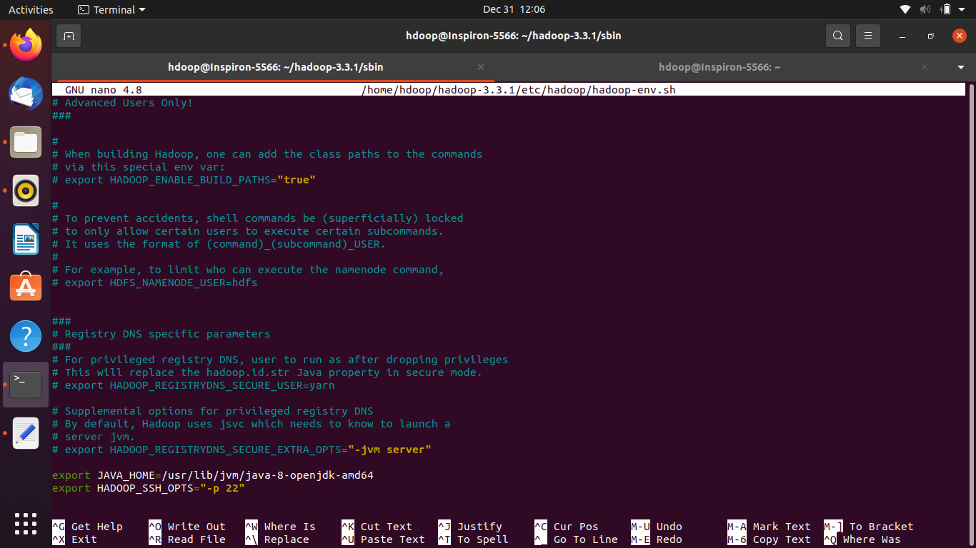

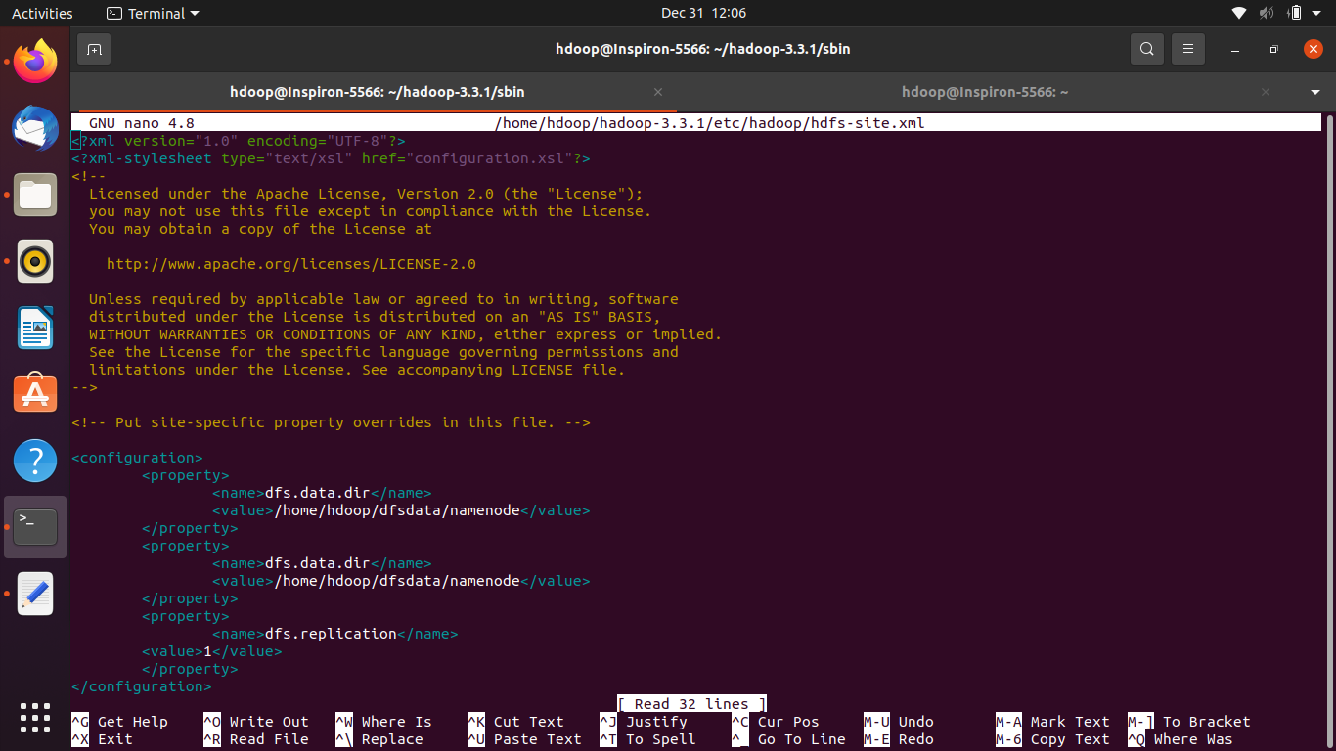

$ **nano etc/hadoop/hdfs-site.xml**

<configuration>

<property>

<name>dfs.replication</name>

<value>1</value>

</property>

<property>

<name>dfs.block.size</name>

<value>128000000</value>

</property>

</configuration>

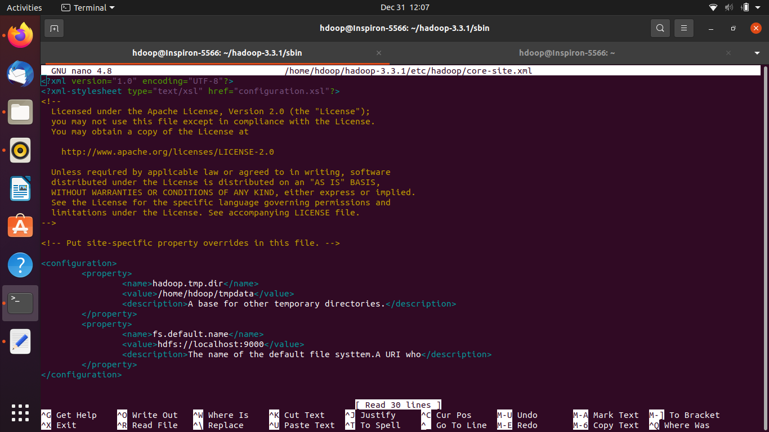

$ **nano etc/hadoop/core-site.xml**

<configuration>

<property>

<name>[fs.default.name](http://fs.default.name) </name>

<value>hdfs://localhost:9000</value>

</property>

<property>

<name>hadoop.tmp.dir</name>

<value>/home/nida/hadoop-3.2.2/etc/hadoop/hadoopt

mp</value>

</property>

</configuration>

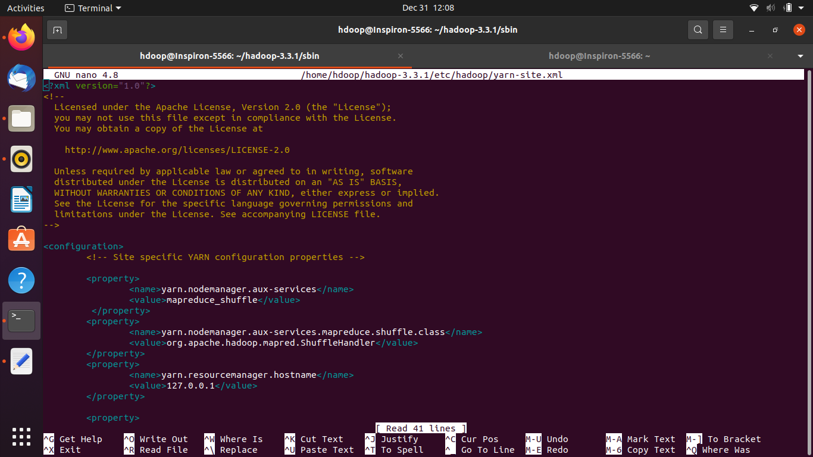

**$ nano etc/hadoop/yarn-site.xml**

<configuration>

<property>

<name>yarn.nodemanager.aux-services</name>

<value>mapreduce_shuffle</value>

</property>

<property>

<name>yarn.nodemanager.aux-services.mapreduce.shuffle.

class</name>

<value>org.apache.hadoop.mapred.ShuffleHandler</value>

</property>

</configuration>

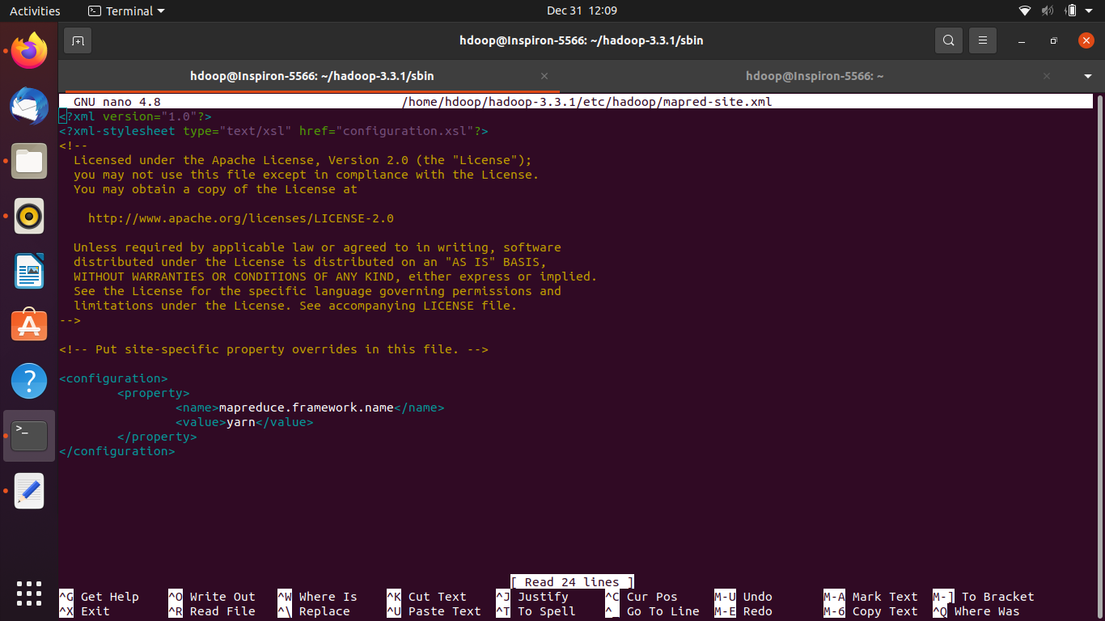

$ **nano etc/hadoop/mapred-site.xml**

<configuration>

<property>

<name>yarn.app.mapreduce.am.env</name>

<value>HADOOP_MAPRED_HOME=$HADOOP_HOME</value>

</property>

<property>

<name>mapreduce.map.env</name>

<value>HADOOP_MAPRED_HOME=$HADOOP_HOME</value>

</property>

<property>

<name>mapreduce.reduce.env</name>

<value>HADOOP_MAPRED_HOME=$HADOOP_HOME</value>

</property>

<property>

<name>[mapreduce.framework.name](http://mapreduce.framework.name)</name>

<value>yarn</value>

</property>

</configuration>

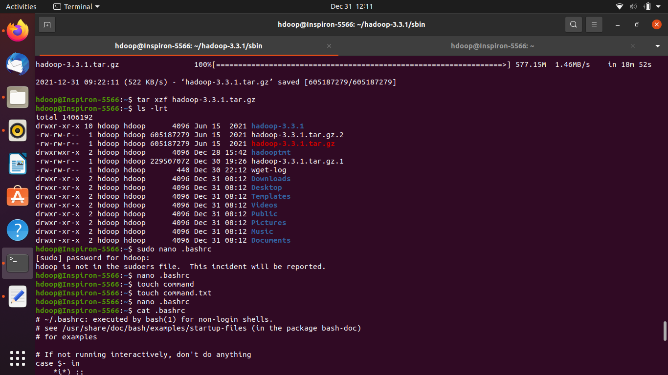

## **Configuration Files** are the files which are located in the extracted tar.gz file in the etc/hadoop/ directory.

All Configuration Files in [**Hadoop**](https://data-flair.training/blogs/hadoop-introduction-tutorial-quick-guide/) are listed below,

**1) HADOOP-ENV.sh**->>It specifies the environment variables that affect the JDK used by Hadoop Daemon (bin/hadoop). We know that Hadoop framework is wriiten in Java and uses JRE so one of the environment variable in Hadoop Daemons is $Java_Home in Hadoop-env.sh.

**2) CORE-SITE.XML**->>It is one of the important configuration files which is required for runtime environment settings of a Hadoop cluster.It informs Hadoop daemons where the NAMENODE runs in the cluster. It also informs the Name Node as to which IP and ports it should bind.

**3) HDFS-SITE.XML**->>It is one of the important configuration files which is required for runtime environment settings of a Hadoop. It contains the configuration settings for NAMENODE, DATANODE, SECONDARYNODE. It is used to specify default block replication. The actual number of replications can also be specified when the file is created,

**4) MAPRED-SITE.XML**->>It is one of the important configuration files which is required for runtime environment settings of a Hadoop. It contains the configuration settings for [**MapReduce**](https://data-flair.training/blogs/hadoop-mapreduce-introduction-tutorial-comprehensive-guide/) . In this file, we specify a framework name for MapReduce, by setting the MapReduce.framework.name.

**5) Masters**->>It is used to determine the master Nodes in [**Hadoop cluster**](https://data-flair.training/blogs/install-cloudera-hadoop-cdh5-ubuntu/). It will inform about the location of SECONDARY NAMENODE to Hadoop Daemon.

The Mater File on Slave node is blank.

**6) Slave**->>It is used to determine the slave Nodes in Hadoop cluster.

The Slave file at Master Node contains a list of hosts, one per line.

The Slave file at Slave server contains IP address of Slave nodes.

**yarn-site.xml:**

This file contains the configuration settings related to [**YARN**](https://data-flair.training/blogs/hadoop-yarn-tutorial/) . For example, it contains settings for **Node Manager, Resource Manager, Containers,** and **Application Master**.

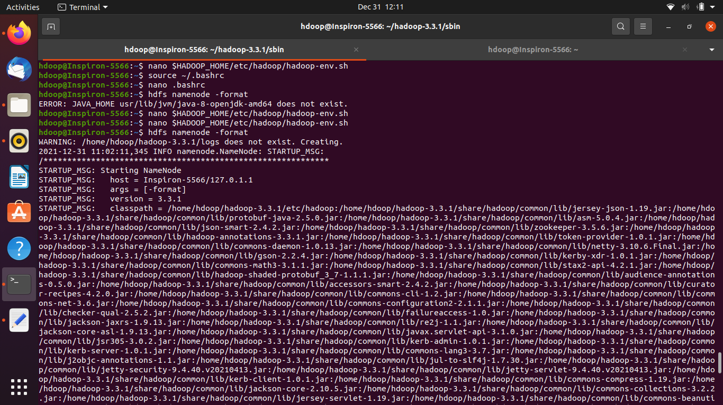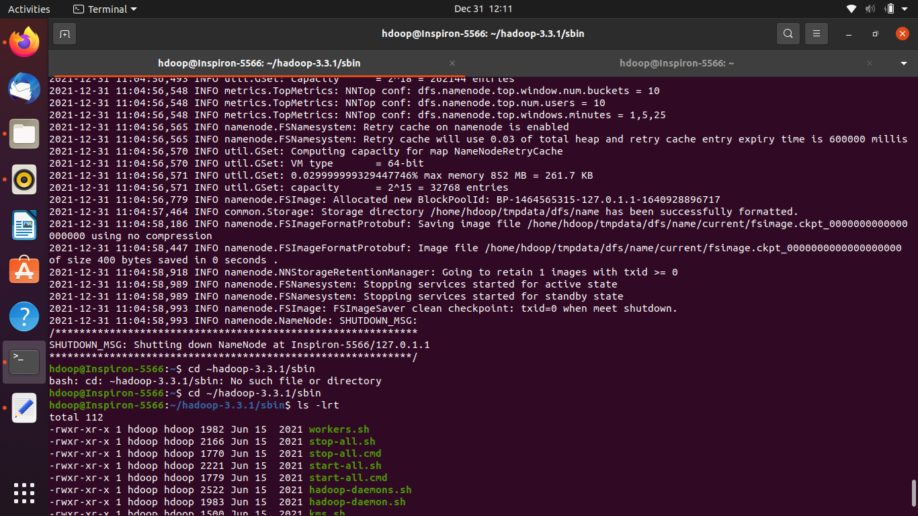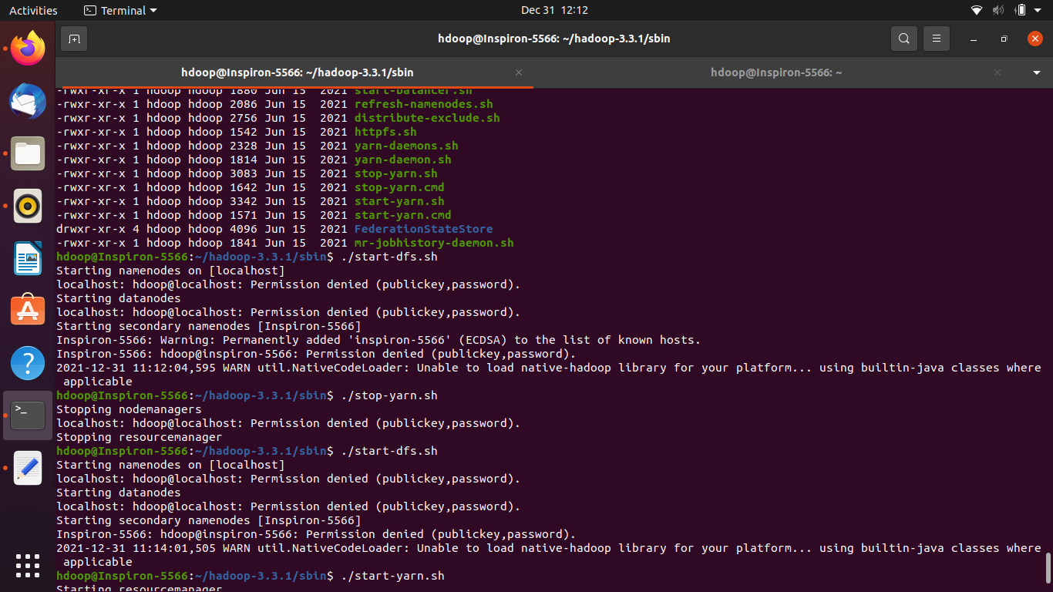

# Basic file Operations

$ hadoop fs -mkdir /user/dir

$ hadoop fs -ls /user

$ hadoop fs -ls /user

$ hadoop fs -ls /user/dir

Output:

2021-12-31 14:16:15,469 WARN util.NativeCodeLoader: Unable to load native-hadoop library for your platform... using builtin-java classes where applicable

Found 1 items

-rw-r--r-- 1 hdoop supergroup 20 2021-12-31 14:12 /user/dir/test.txt

$ hadoop fs -cat /user/dir/test.txt

Output:

2021-12-31 14:17:37,512 WARN util.NativeCodeLoader: Unable to load native-hadoop library for your platform... using builtin-java classes where applicable

This is a test file

$ rm -rf hadoop-3.3.1.tar.gz

hdoop@Inspiron-5566:~$ rm -rf hadoop-3.3.1-archive.tar.gz

hdoop@Inspiron-5566:~$

hdoop@Inspiron-5566:~$ wget https://downloads.apache.org/hadoop/common/hadoop-3.3.1/hadoop-3.3.1.tar.gz

# Word Count Program

$ hadoop jar '/home/hdoop/wordcount/WordCount.jar' WordCount /wordcount/input /wordcount/output

hdfs dfs -cat /wordcount/output/*

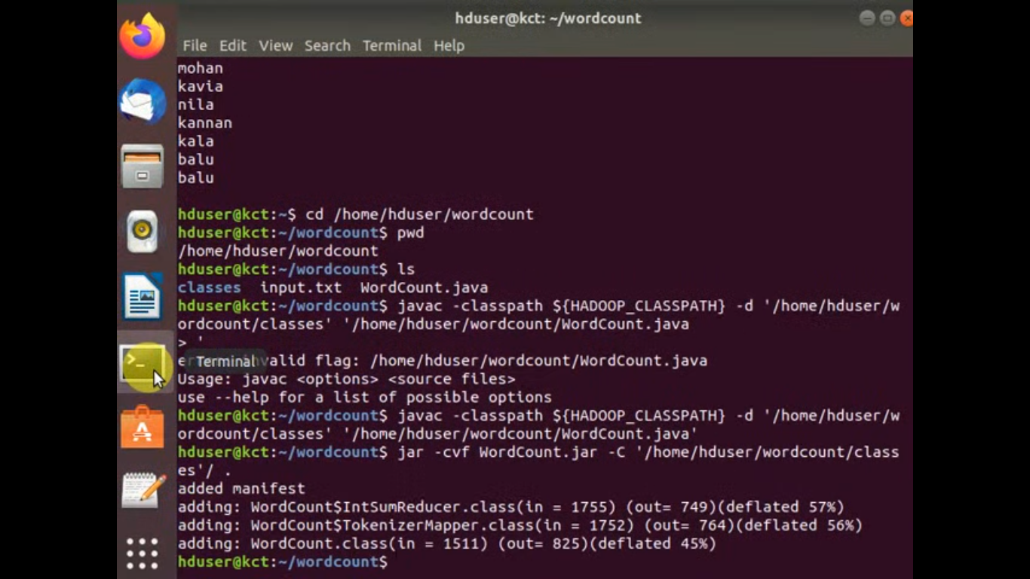

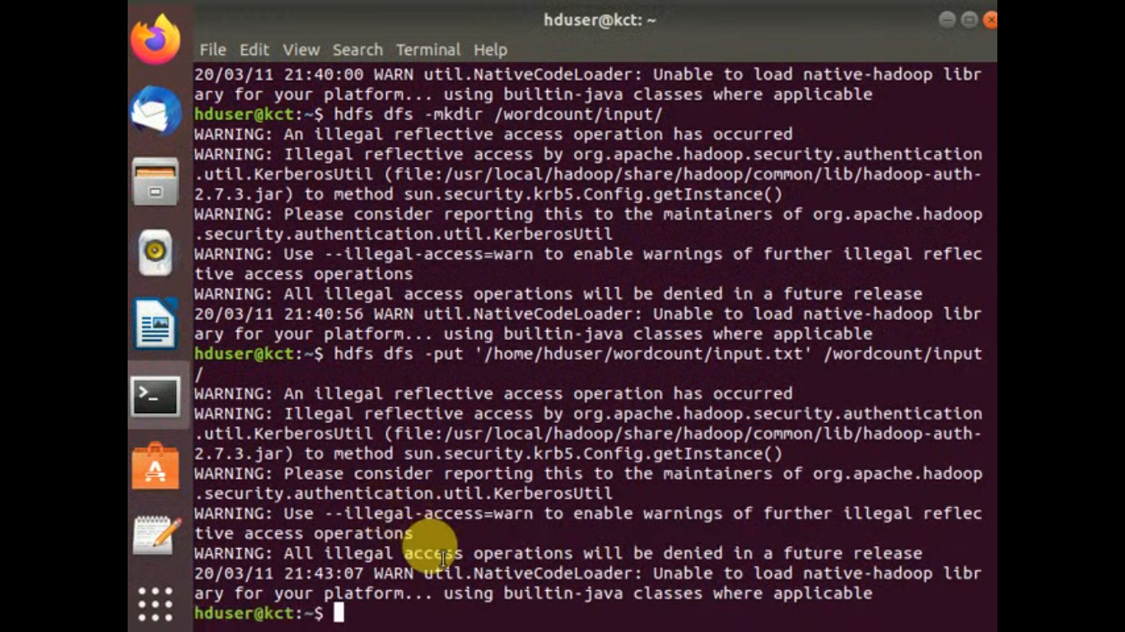

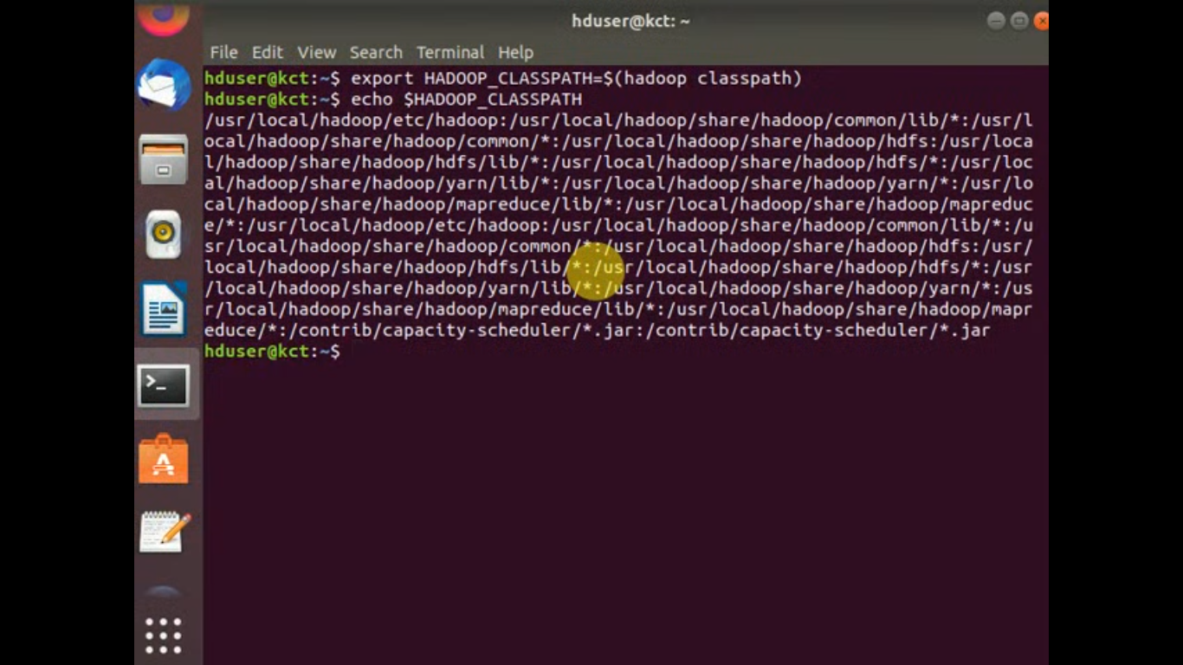

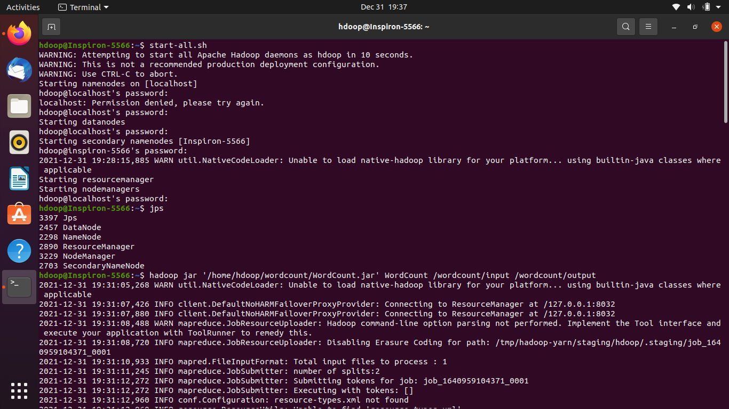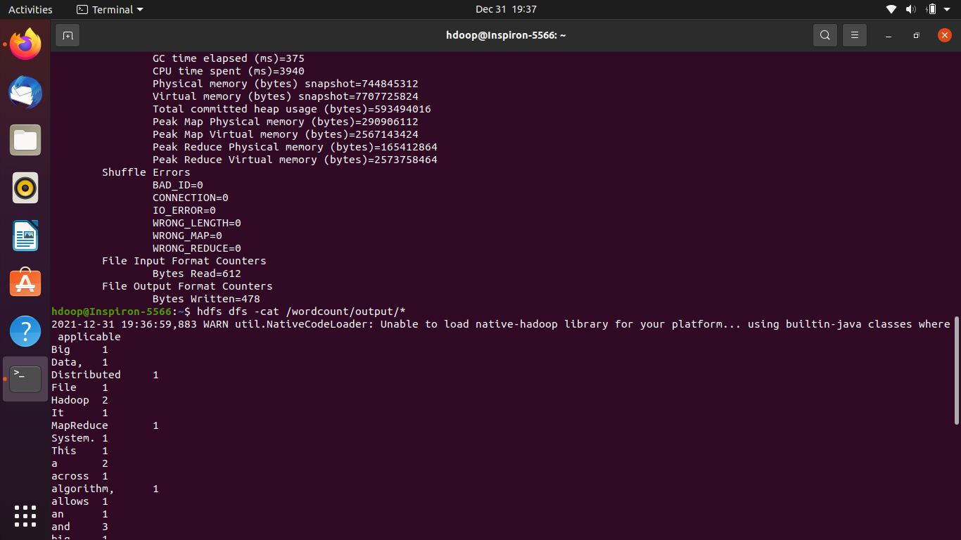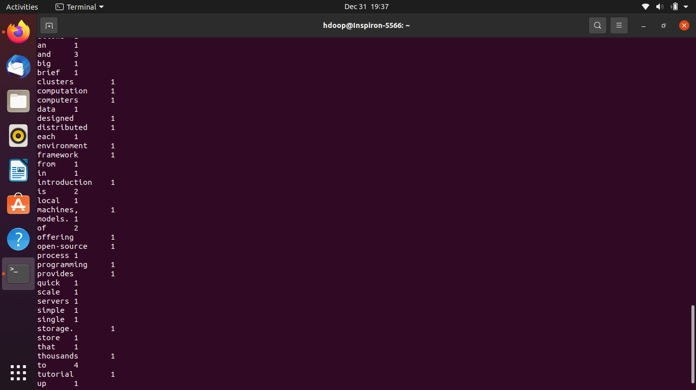

## Uploading files into hdfs files:

$ hdfs dfs -put samples/sample.json /Files/input/

$ hdfs dfs -ls /Files/input

2022-01-04 09:39:35,993 WARN util.NativeCodeLoader: Unable to load native-hadoop library for your platform... using builtin-java classes where applicable

Found 2 items

-rw-r--r-- 1 hdoop supergroup 127 2022-01-04 09:38 /Files/input/sample.json

-rw-r--r-- 1 hdoop supergroup 20 2022-01-04 09:37 /Files/input/test.txt

$ hdfs dfs -cat /Files/input/sample.json

2022-01-04 09:40:25,118 WARN util.NativeCodeLoader: Unable to load native-hadoop library for your platform... using builtin-java classes where applicable

{"name":"gil","age":48,"city":"london"}

{"name":"jane","age":30,"city":"new york"}

{"name":"jordan","age":18,"city":"toronto"}

hdfs dfs -put samples/annual-enterprise /Files/input/file.csv

hdfs dfs -ls /Files/input/

hdfs dfs -ls /Files/input/

2022-01-04 10:56:02,839 WARN util.NativeCodeLoader: Unable to load native-hadoop library for your platform... using builtin-java classes where applicable

Found 3 items

-rw-r--r-- 1 hdoop supergroup 5881081 2022-01-04 10:52 /Files/input/file.csv

-rw-r--r-- 1 hdoop supergroup 127 2022-01-04 09:38 /Files/input/sample.json

-rw-r--r-- 1 hdoop supergroup 20 2022-01-04 09:37 /Files/input/test.txt

hdfs dfs -cat /Files/input/file.csv

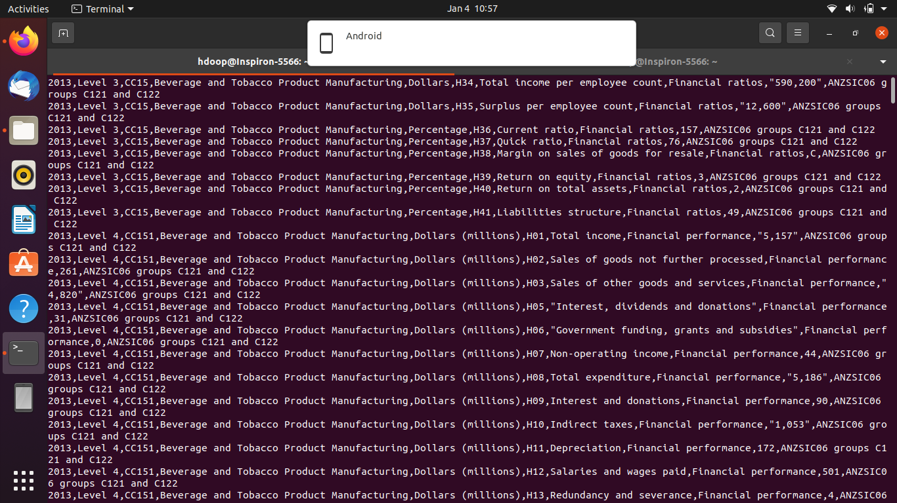

$ hdfs dfs -ls /Files/input/

2022-01-04 16:18:55,464 WARN util.NativeCodeLoader: Unable to load native-hadoop library for your platform... using builtin-java classes where applicable

Found 6 items

-rw-r--r-- 1 hdoop supergroup 677528 2022-01-04 16:18 /Files/input/cpulogdata.csv

-rw-r--r-- 1 hdoop supergroup 93561 2022-01-04 15:40 /Files/input/file.avro

-rw-r--r-- 1 hdoop supergroup 5881081 2022-01-04 10:52 /Files/input/file.csv

-rw-r--r-- 1 hdoop supergroup 113629 2022-01-04 15:58 /Files/input/file.parquet

-rw-r--r-- 1 hdoop supergroup 127 2022-01-04 09:38 /Files/input/sample.json

-rw-r--r-- 1 hdoop supergroup 20 2022-01-04 09:37 /Files/input/test.txt

$ hdfs dfs -cat /Files/input/cpulogdata.csv

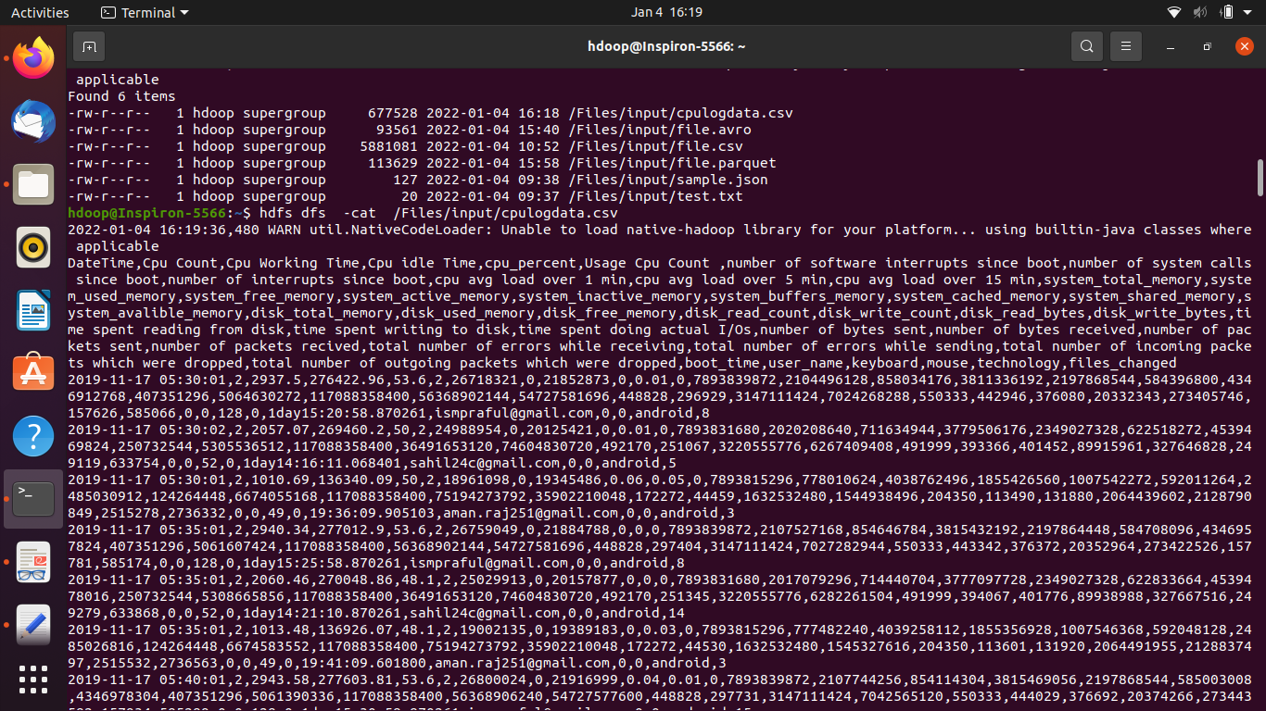

$pip install pyspark

$pip install parquet

$ python3 parq.py

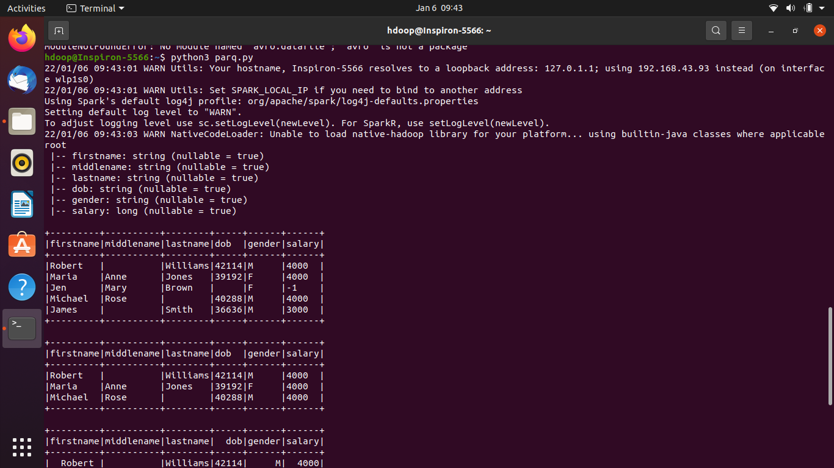

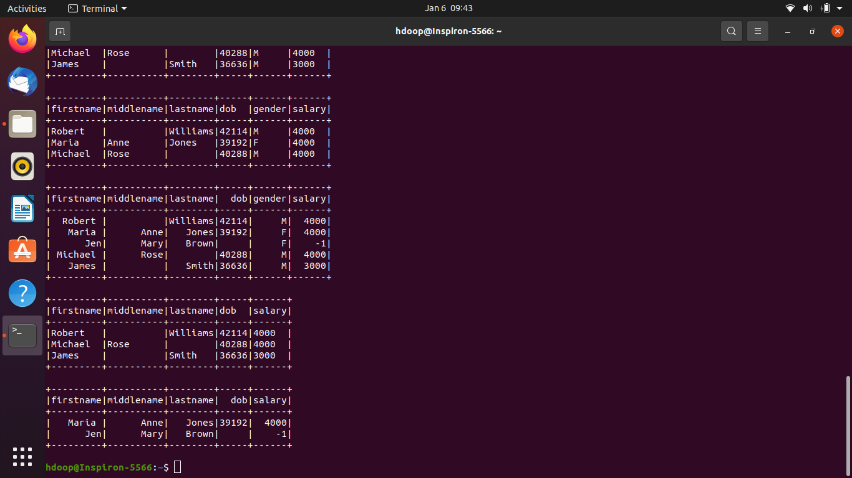

$pip install avro-python3

$ python3 opsavro.py

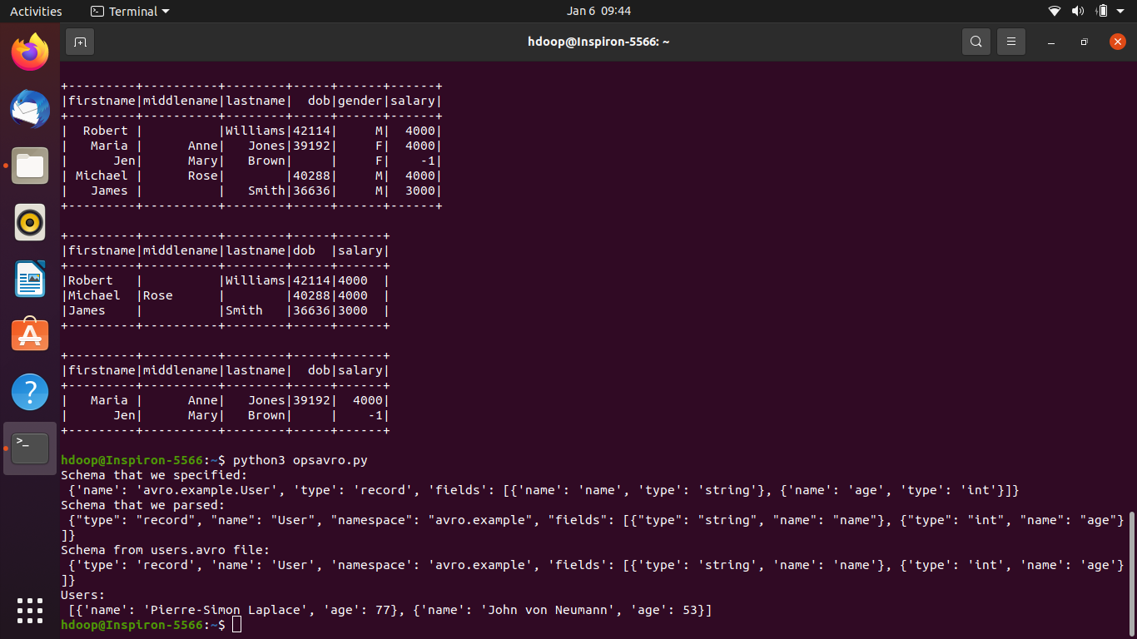

$ hdfs fsck /Files/input/logdata1.csv -files -blocks

O/P:

2022-01-05 10:45:45,269 WARN util.NativeCodeLoader: Unable to load native-hadoop library for your platform... using builtin-java classes where applicable

Connecting to namenode via http://localhost:9870/fsck?ugi=hdoop&files=1&blocks=1&path=%2Ftmp%2Fcpulogdata.csv

FSCK started by hdoop (auth:SIMPLE) from /127.0.0.1 for path /tmp/cpulogdata.csv at Wed Jan 05 10:45:46 IST 2022

/tmp/cpulogdata.csv 677528 bytes, replicated: replication=1, 1 block(s): OK

0. BP-1464565315-127.0.1.1-1640928896717:blk_1073741850_1026 len=677528 Live_repl=1

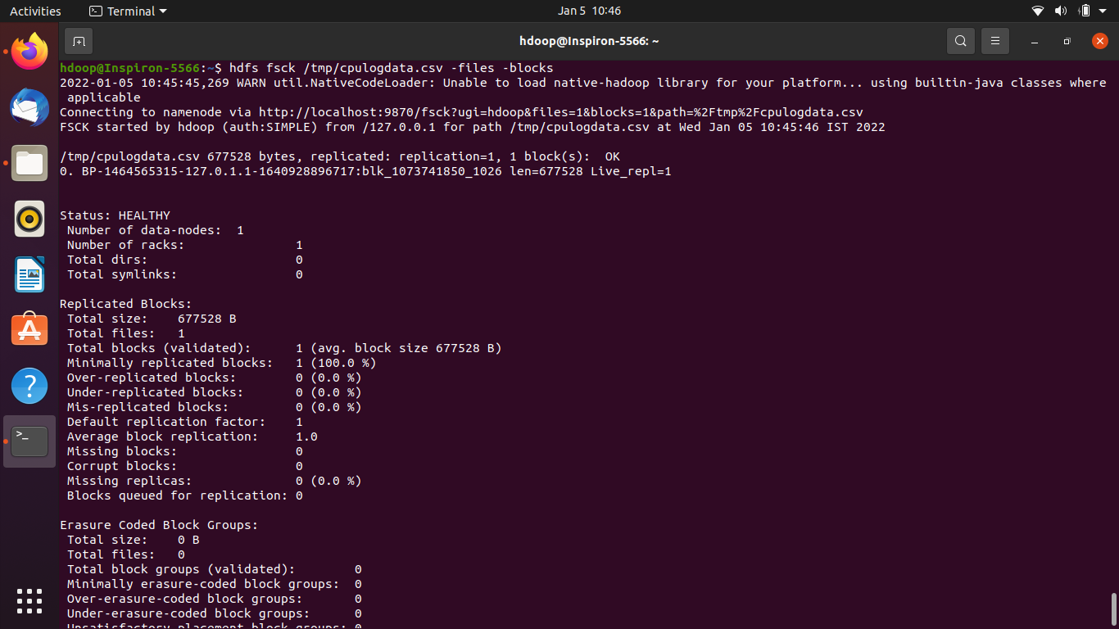

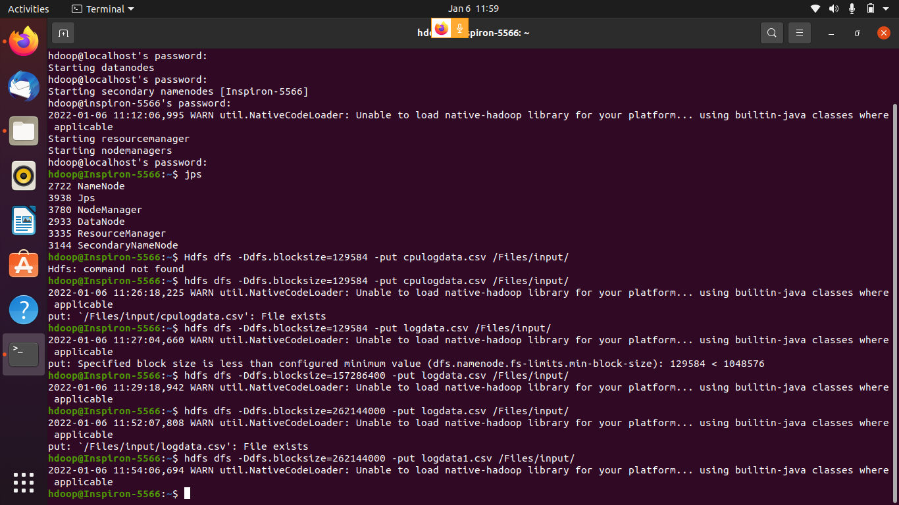

Hdfs dfs -Ddfs.blocksize=262144000 -put logdata.csv(This file is on my home) /Files/input/

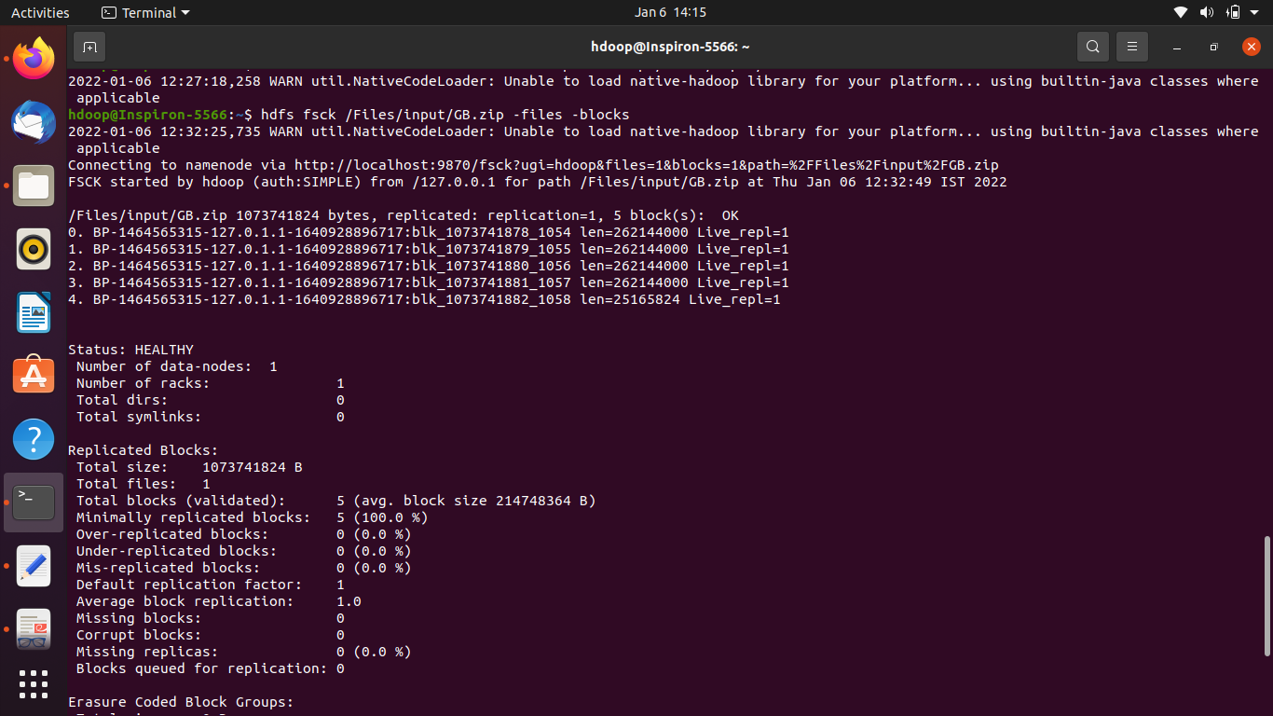

**ZOOKEEPER :**

-what is Zookeeper

---Distributed,open source coordination service for distributed applications

--- it exposes a simple set of primitives to implement higher level services for synchronization ,configuration maintenance and groups and naming

---designed to be easy to program and use

---runs in java and has bindings for both java ,python,c

---used in yahoo,twitter,Netflix and fb

Use of ZOOKEEPER : to make coordination easy in distributed environments so that we don’t need to implement our own coordination services from scratch

**Problem :**

--coordination services: the integration /communication of services in a distributed environment

--coordination services hard as they are especially prone to errors such as race conditions,deadlocks

RACE CONDITION: Two or more systems trying to perform the same task

DEADLOCK : Two or more operations waiting for each other for infinite time

**What is Distributed Systems:**

---network that consists of autonomous computers that are connected using a distribution middleware

**KEY FEATURES:**

TRANSPARENCY :hiding complexity and showing functionality

RELIABILITY : secure,consistent

OPENES,PERFORMANCE,SCALABILITY

**CHALLENGES :**

SECURITY : in times of usage of public clouds

FAULT TOLERANCE : component built on unreliable component

COORDINATION AND RESOURCE SHARING : if proper policies not followed

**Coordination challenge :(in distributed systems)**

Master node where cluster data is stored

worker nodes/slave nodes get data from the master node

if master node fails ;suppose if master node is fault tolerant it should reflect in slave nodes

synchronization is not easy ----careful design ,implementation needed

to increase availability more systems added in which coordination can be difficult

**APACHE ZOOKEEPER :**

Software of apache software foundation

--it provides open source coordination solutions to various coordination pblms to ds

--zookeeper is centralized coordination service which runs on cluster of servers called “ZOOKEEPER ENSEMBLE”

**ZOOKEEPER ARCHITECTURE :**

**2 TYPES OF NODES --->LEADER,FOLLOWER**

**LEADER NODE :responsible for processing write request**

**FOLLOWER NODE : delegate write client nodes to leader nodes**

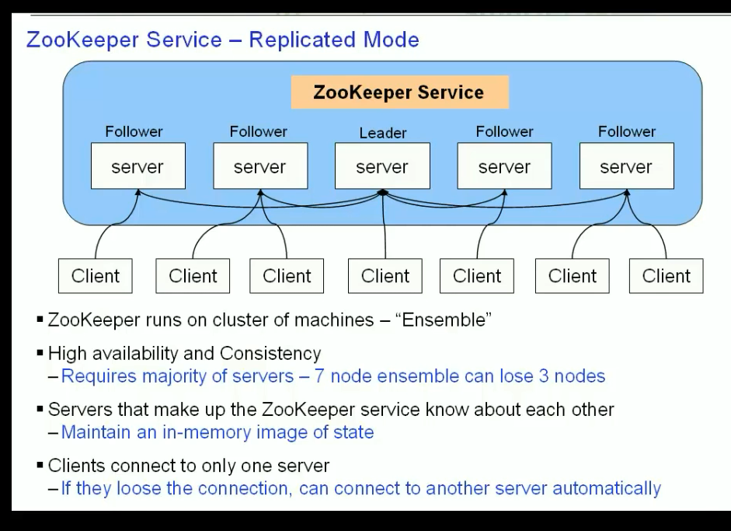

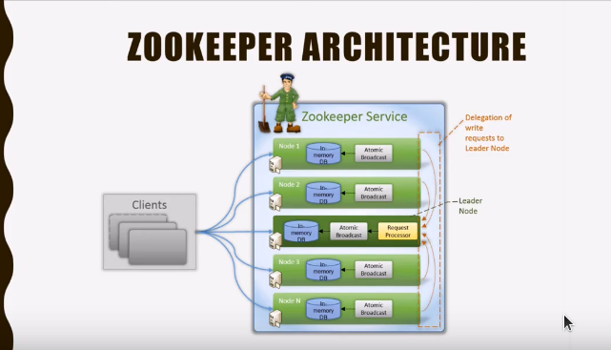

Leader node elected internally by all nodes of cluster ;the node that receives major no of votes it will be considered as leader node

--only odd no of nodes to be used while setting up cluster(7,5 etc)

Follower node: capable of serving read request on its own;

for write request it is done through leader node

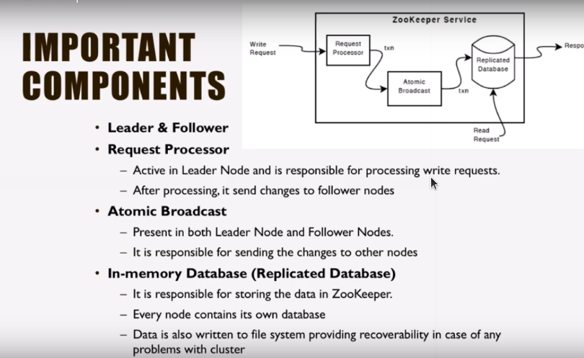

**OTHER COMPONENTS :**

--CLIENT : one of nodes in distributed application cluster

Access info from server

Every client sends msg to server to let server know that client is alive

If client don’t receive acknowledgement from server it will send to another server

---SERVER : provides all services to clients

Gives acknowledgement to clients

---ENSEMBLE : group of zookeeper servers

Minimum no of nodes required to form an ensemble is 3

**ZNODES :**

--Every node in zookeeper tree is referred as ZNODE

---ZNODE maintains stat structure consists of :

-------version number :changes if znode gets changed

-------ACL :Authentication mechanism for accessing znodes represents read,write permissions on znodes.

-------TIMESTAMP : time elapses from znode creation and modification (millisec)

-------DATA LENGTH :total amt of data stored in znode(max 1mb)

TYPES OF ZNODES :

**-PERSISTENCE :** Alive until removed explicitly

**-EPHEMERAL :** Active until client connection is alive

**-SEQUENTIAL :** Either persistent or ephemeral

**SESSIONS AND WATCHES :**

Sessions :

established as soon as zookeeper client connects to server

->Requests in sessions are executed in FIFO order

-> session established then session id is assigned to client

->client sends heartbeats(signals) to keep the session valid

->session timeout are usually represented in millisec

Watches :

->watches are mechanism for clients to get notifications about the changes in zookeeper

->clients can set watches while reading a particular znode

->znode changes are modifications of data associated with znode or changes in znode’s children

->watches are triggered only once

->if session is expired,watches are also removed

<https://www.apache.org/dyn/closer.lua/zookeeper/zookeeper-3.7.0/apache-zookeeper-3.7.0.tar.gz>

tar -xvf apache-zookeeper-3.7.0.tar.gz

$ gedit .bashrc

export ZOOKEEPER_HOME=/home/hdoop/zookeeper/apache-zookeeper-3.7.0

export PATH=$PATH:$ZOOKEEPER_HOME/bin

export PATH=$PATH:$HADOOP_HOME/sbin:$HADOOP_HOME/bin

source .bashrc

zkServer.sh start

$ zkServer.sh start

/usr/bin/java

ZooKeeper JMX enabled by default

Using config: /home/hdoop/zookeeper/apache-zookeeper-3.7.0/bin/../conf/zoo.cfg

Starting zookeeper ... STARTED

**OOZIE :**

**What is Apache Oozie ?**

---is a job scheduling system designed and deployed to manage and run Hadoop jobs in distributed storage environments; it allows users to combine multiple jobs to run in sequential order to achieve a higher order job to be finished.

**Why do we use Oozie?**

--- its capability to strongly find and integrate itself with hadoop jobs like HIVE,SCALA,APACHE epic ,SPARK and many more

---Oozie open source java web application available under apache license 2.0

---Responsible for triggering workflow actions which in turn uses hadoop execution engine to actually execute the task

**Helps in** : load balancing, system failover and many more

Oozie detects completion of tasks through callback and pollen ; when oozie starts a task it provides unique callback HTTP URL to tasks and notifies the URL when task is completed; if task fails to invoke the callback URL then oozie can pull the task for completion.

**Types of Apache Oozie Jobs :**

1. **Work-Flow Jobs :** are DAGs specifying sequence of actions to be executed.

The actions will be carried out in sequence i.e., the output of previous action will be input for present action ;output of present action will be input for next upcoming action.

To execute some tasks in parallel we use fork option :

JOIN : to merge two parallel tasks into one

START,END : to start and end phase( using Mapreduce job,pig job,hive job)

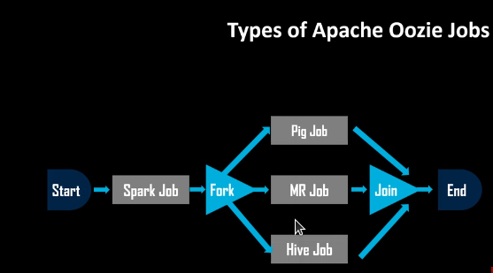

**2)Coordinator jobs :** consists of workflow jobs triggered by time and data availability.

Oozie coordinators trigger the workflows jobs based on time,data/event predicates.

The workflows inside the job coordinator start when the given condition is satisfied.

**DEFINITIONS :**

**START :** data and time for particular job assigned

**END :** date and time for particular job assigned

**TIME ZONE :** represents time zone of coordinator application where the programis

executed based on particular location

**Frequency :** info about no of minutes consumed while executing the job

**TIMEOUT :** max. Time in minutes for which an action will be satisfied for additional conditions before getting discarded;

0 ---all inputs are satisfied at time of action materials

1--- no time out ---actions wait forever;actions to be turned out immediately

Default ---1

**CONCURRENCY :** max no of jobs that can run parallel( default---1)

**EXECUTION :** execution order if multiple instances of coordinator job have to be satisfied with the execution drive area that can be FIFO by default.

**(FIFO, LIFO,LAST_ONLY)**

**3) Bundles :** referred to as a package of multiple coordinators and workflow jobs .

Execute a set of multiple coordinator services called DATA PIPELINE.

Start,stop,suspend,resume,re-run the bundle;

Gives better and easy operation control .

Kickoff time ----> is time when bundle should start and submit coordinator application

**Advantages of Oozie :**

**---Scalable ;**

**---Reliable ;** --to monitor jobs in hadoop cluster

**--- Supports in(various jobs) Hadoop Ecosystem** ----> like Pig,Hive,Mapreduce and java based applications

**--- Extensible Architecture** ---> supports great programming paradigms

**--- Complex Workflow action and Dependencies-**----> workflow consists of actions and dependencies among them followed by complex workflow action dependencies;

**--- Reduced Time to market** ----> saves lot of time to market

**--- Frequency Execution** ---> users can specify execution frequency and can wait for data arrivals to trigger an action on the workflow

**--- Hadoop Stack Integration-**--> Oozie supports all types of jobs such as Spark,hive,pig;

Oozie is validated against hadoop stack and integrated with Yahoo distribution of hadoop with security and is primary mechanism to manage a variety of complex data analysis

**Three main control flow nodes in OOZIE :**

**START,KILL,END** (if MR job faces error then it can be terminated using kill node)

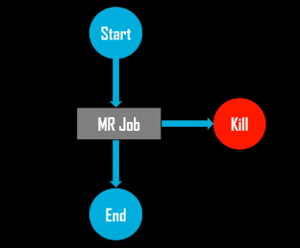

**OOZIE ARCHITECTURE :**

